Planning Prayer and Liturgy for those with particular needs

A **fourth** guide to accompany

‘**To love you more dearly’**,

the Prayer and Liturgy Directory

for Catholic Schools, Academies and Colleges in England and Wales

March 2025

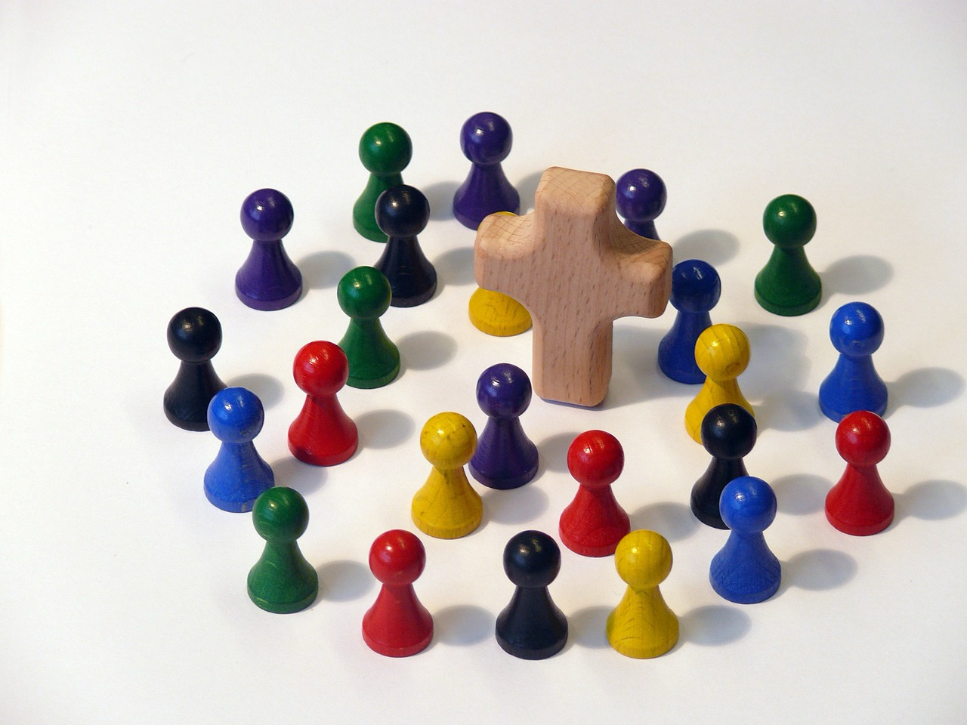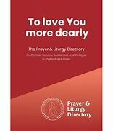

***CONTENTS***

***Section Page***

*Foreword, Aims and Acknowledgements 3*

*Introduction 4*

*Seasonality and SEND 5*

*Scripture and SEND 6*

*Senses and SEND 7*

*Structure and SEND 8*

*Further resources 9*

# Foreword

*Prayer and Worship are at the heart of the Christian life. It is through our personal prayer and public worship that we grow in understanding, knowledge and love of our God, who is Father, Son and Holy Spirit.*

*Parents are the first nourishers of a life of prayer for their children, but as teachers in a Catholic School, you are charged in a particular way with this holy task.*

*I hope that these guidelines will help support you in this.*

*Also, I would like to take the opportunity to thank other Dioceses and individuals whose generosity in sharing resources have made this document possible. A particularly warm expression of thanks to Alan Dewhurst in pulling the material together making it accessible to all.*

***Rt Rev Ralph Heskett CSsR, Bishop of Hallam***

# Aims of this document

The purpose of this guide is to support schools in their planning and preparation of the opportunities for prayer in their communities, following the publication of the Prayer and Liturgy Directory for Schools – **To love you more dearly** – with full implementation from September 2025.

It is designed to be of practical help for all who work in schools and have responsibility for preparing and leading prayer, in whatever setting. Through the use of these guidelines, it is hoped that all members of a school’s community will have regular opportunities, in age-appropriate manner, to encounter God in prayer, to experience His love, to deepen their understanding of faith.

**The focus of this particular document is to help schools to make prayer and liturgy accessible to those who may find difficulty, for whatever reason, in being included because of their special educational needs or disabilities.**

# Acknowledgements

The Diocese of Hallam acknowledges the generosity of other dioceses in England in allowing the adaptation of the resources they have produced in support of The Prayer and Liturgy Directory. In particular, grateful thanks are given to:

* Tom Baptist, Director of Chaplaincy, Our Lady of Lourdes CMAT, for his inspirational insight and creativity in designing resources for use in schools.
* The Dioceses of Nottingham, Westminster and Leeds
* Advice received from clergy, teachers and lay chaplains within Hallam Diocese.

# Introduction

***SEND: Special Educational Needs and Disabilities***

***[Those with SEND] come first to mind. They have a right, like others of their age, to know ‘the mystery of faith.’ The greater difficulties that they encounter give greater merit to their efforts and to those of their teachers.***

*– Saint Pope John Paul II, Catechesi Tradendae #41*

*Prayer and liturgy should be inclusive and accessible to all, and the perspectives and approaches we take to support those within our community with SEND will be* ***essential to some, but beneficial to all.*** *We must remove the barriers that many young people face, and our prayer and liturgy should be an inclusive example of best practice.*

*In his ministry, Jesus would break down the social barriers towards inclusion and acceptance and that is what we are called to do in our ministry. Jesus dignified those he met, especially those who faced significant challenges in life. He would listen, and he would respond with love.*

*Underpinning all of the approaches in this resource, should be a commitment to affirm the dignity of all those who we are serving by seeking their voice, their views and their input. To ensure everyone can fully, consciously and actively participate we must not remove agency and at all times we must act with compassion and care.*

*To enable the best possible inclusive practice, each of the four lenses included in this document will also give some specific SEND guidance to inform the way we work. As with the broader principles presented in this resource, none of the guidance around the four areas can or should be used in isolation. Each lens, and the SEND approaches contained within, must inform the others.*

*Often the complex and individual nature of need calls us to use a wide variety of strategies to support every individual in a truly holistic approach. We are called to recognise and celebrate the ‘unity in our diversity’ so that we can create a truly authentic inclusion for all.*

***Unity does not imply uniformity; it does not necessarily mean doing everything together or thinking in the same way. Nor does it signify a loss of identity. Unity in diversity is actually the opposite: it involves the joyful recognition and acceptance of the various gifts which the Holy Spirit gives to each one and the placing of these gifts at the service of all members of the Church.*** *– Pope Francis, Address, October 2014*

# Seasonality and SEND

***Safe and Included***

*The space and time we give to communal and personal prayer can be a real positive for those in our community with SEND. Often the safe spaces we create at these times can help all young people to explore and process difficult feelings and emotions and help them to connect with their community. Safeguarding these times for prayer and liturgy is then of the upmost importance, as is making sure that everyone feels welcome and included.*

*Over the course of a year the distinct feeling that we can give to each liturgical season, such as calm and quiet times during Lent, can help young people engage in genuine and meaningful ways. If you are working with young people with SEND, think about how you can integrate whole school seasonal elements into the everyday experiences in the classroom or other spaces that you use. Creating a bridge of familiar experiences between the usual and sacred spaces in schools will help create a more consistent, stable and familiar environment which all helps to facilitate authentic participation.*

***The Physical Space***

*When considering those with SEND, the physical environment is something we need to give particular attention to. Think about how you might enter and exit a space, how people will be seated and ensure there is space for easy movement. Make sure those young people who may require time out, or who may find elements difficult, can sit near an exit and that routes out of any space are clearly visible and accessible.*

*The positioning of staff supporting young people is also something to consider so that you can create a sense of safety and security for the young people as they gather.*

*While making special consideration for young people with SEND try, where possible, to ensure that they are not separated or detached from the group. Consider, for example, if not everyone can sit on the floor, can everyone be seated so everyone is on the same level? It is also important that elements like the focus, or the screen are clearly visible to all as this can help everybody to be more engaged and more connected. In all of these approaches, always seek the voice of the young people themselves. Where we can give choices and respect their dignity, we enable them to feel secure and empower them to authentically participate.*

***Content***

*There are many themes, stories and topics within the rhythm of the year which may prove upsetting or uncomfortable for members of the community. Consideration should always be given to the appropriate use of scripture and how to explore themes with young people who may find it difficult. Exploring death and loss, families and relationships, or sin and forgiveness could all be challenging for those involved. A positive, open and honest dialogue can help young people and staff to prepare for these times, and working with those with SEND ahead of such topics to prepare them for what you are exploring can help them to continue to play an active part. If it is decided that it would not be suitable for young people themselves to take part in a specific event, then all care should be taken to find a meaningful way for them to be connected and included. This could include a separate service or involvement with aspects of the preparation.*

# Scripture and SEND

***The written word***

*The written word is a fundamental part of our liturgical tradition. It can also, however, be a barrier to inclusion and where possible every accommodation should be made to support young people to engage with the texts and scripture that we use. With scripture, the use of suitable translations (such as the* ***Good News Text*** *in primary) can be a good start, but where pastoral demands require it, simpler texts, and pictorial resources that can accompany a full translation can be used.*

*A copy of any scripture to be read, or significant texts to be used, could also be displayed either in a booklet or on a screen to accompany the spoken word, to support those who may find it harder to listen or understand.*

*Scripture should always be presented in line with our liturgical tradition. However, in addition to this, it can be helpful to use other resources alongside the text to scaffold understanding. This could be in the form of videos, music, visual aids etc. These should not be a replacement for, but an addition to, the scripture in our prayer and liturgy so that all can share in the Word of God.*

***Screens and displays***

*When using screens and displays it’s important to work closely with your SENDCo to observe best practice particularly to support those young people who find text and the written word challenging. Using large, clear, sans serif fonts, not displaying too much text at a time, and using high contrast text on a tinted (non-white) background are just some of the ways to improve readability and this should be considered whenever we use the written word and scripture as part of prayer and liturgy.*

*Where writing and communication are an active part of the prayer and liturgy itself, such as writing on a prayer wall or answering a question, care and consideration must also be given to those who may find it hard to participate. Writing aids, digital devices and staff support can all help those who may find it challenging to take part, but this needs to be well planned. Where possible, always try to find actions or activities that allow everyone to participate in the same way before making any special adaptations for individuals.*

***Instruction***

*How we lead people and direct them through prayer and liturgy is key to ensuring they are able to engage in a meaningful way. Careful planning of how we ask people to take part in specific actions should be considered during both planning and delivery. Before a particular celebration it is important to prepare young people for their role and for what they will experience. Young people need to understand clearly what they will be asked to do and why. As always, we should listen to the young people themselves to understand what they are comfortable doing and what we can do to facilitate it. It may be helpful to practise an action or activity first, so that it is familiar.*

*When leading prayer and liturgy, consider how to scaffold the delivery of information. This gives people time to prepare and an indication of what to expect. Phrases such as ‘In a moment we will be...’ or ‘After the next hymn we will...’ for example, help all those gathered to know clearly what is happening. It also gives time for people to process, and creates a greater sense of security and safety. When giving instructions it also important that  
you are specific, clear and direct. The use of visuals for individuals may support this further. Try also to explain why you are doing something to aid deeper understanding. These approaches in particular, can benefit everyone present and ensure that the prayer and liturgy celebrated is accessible to all.*

# Senses and SEND

***The ‘language of the senses’***

*The ‘language of the senses’ weaves and connects everyone present in prayer and liturgy. It helps everyone to be connected and to engage.*

*How we use the ‘language of the senses’ is of vital importance when working with those in our community with SEND. Often approaches involving the use of our senses can provide a bridge to help others connect - but it can also present a challenge to those who face barriers with sensory input. We must be mindful of the different sensory needs of all those who are present and make adjustments where necessary to ensure that all can feel safe and secure.*

*When thinking about the environment and atmosphere we want to create, we must consider specific sensory needs. Consider if a space, environment or activity would be comfortable for young people and where possible, allow them to see and assess the spaces and environments to be used in preparation. Reflecting on whether a space will be too light or dark, loud or quiet, even crowded or spacious can help us consider the sensory needs of others.*

***Mobility***

*One of the key considerations is making sure the space, gestures, objects and activities are suitable for those with physical needs too. Think carefully about the way people will move, the objects or actions that are to be shared, and what types of interactions will take place.*

*Supporting the physical needs of those present is a fundamental part of creating the safe and secure environment that is needed, and unless absolutely unavoidable, we should plan and prepare all elements of our prayer and liturgy to be accessible to all.*

*As always, speaking directly to young people with specific needs, and being guided by them, can help you plan and prepare in an authentically inclusive way.*

***Support and Aids***

*Those with SEND may sometimes face additional barriers when using different senses. We need to be mindful of this and use the tools and techniques at our disposal to ensure they are able to meaningfully participate.*

*When planning, think first of the specific physical and sensory needs of your group and allow this to shape your ideas and process from the beginning.*

*If there is a visual impairment, think carefully about how images, actions and symbols can be described and communicated. Think also about how movement, actions and gesture can be made inclusive and accessible.*

*Where there is a hearing impairment, consider the use of visual tools, such as images, props and screens to communicate in a variety of ways. The use of gesture and action to scaffold instructions and movement along with more deliberate support such as microphones, loop systems and sign assisted communication, can also ensure that everyone can be a part of the celebration.*

*The use of support aids and equipment does not negate the need to seek approaches and activities that are accessible to all. Support aids can however, facilitate greater inclusion where this is not possible and ensure greater levels of participation.*

# Structure and SEND

***Now and Next***

*‘Now and next’ is a key approach to use when thinking about structure and supporting those with SEND. Thinking and leading in this way builds inclusivity by helping young people to feel secure in what is happening in the moment and by helping them to prepare for what is going to happen next.*

*The ‘now and next’ approach can be used in many aspects of our planning and delivery. Adding graphics to Power Points which show progress through the Mass, or using pictographic icons / cues in a Mass booklet to inform communal gestures such as sit, kneel, stand are good examples of this. This approach should also be evident in the way in which we lead, explain and guide young people through prayer and liturgy: ‘Now we are going to present the bread and wine which during the eucharistic prayer will then become the Body and Blood of Jesus which we will share at communion,’ for example.*

*Carefully structuring what we do, and then using those structures clearly and consistently, helps us all to journey together and creates an environment of familiarity and safety for all. It also helps all those present to better understand not just what is happening by why is it happening too.*

***Time and Space***

*We all process things differently. During prayer and liturgy there will be many thoughts, ideas and emotions and we need to give space for everyone to process what they are thinking and feeling.*

*Make sure your structures, both in planning and delivery, have space and time for processing and thought. Moments of reflection, silence and prayer help everybody respond in their own way and create opportunities for encounter and an authentic personal response. They also help to ensure that we are using the breadth of expression found in the language of the senses. There should be a balance in our structures between the things we* ***see, hear, think and do*** *so that we are engaging everyone and providing opportunities for all to participate in their own way.*

***A holistic approach***

*Employing all of the strategies shared throughout the different lenses will provide a holistic approach to meeting individual needs and removing barriers and provide opportunities for encounter for everyone within the community.*

*The SEND content within this resource is not intended to be a complete picture of what can be provided. It is simply a starting point for reflection and growth to help us consider how we can reach out and actively include everyone in prayer and liturgy. As stated before, the principles and considerations outlined across all four lenses will be* ***essential to some, but beneficial to all.***

***Further Resources***

* *My Mass Book Picture Missal – National Catholic Partnership on Disability*[***https://www.ncpd.org/resources_and_toolkits/my-mass-book-picture-missal***](https://www.ncpd.org/resources_and_toolkits/my-mass-book-picture-missal)
* *Accepting the Gift – A ministry for Catholic special needs parents* [*https://acceptingthegift.org/resources-for-parishes-and-dioceses/*](https://acceptingthegift.org/resources-for-parishes-and-dioceses/)
* *Adaptive Faith Formation Tools- Diocese of Des Moines* [*https://www.dmdiocese.org/ministries-and-faith-formation/deaf-disability-ministry/faith-tools#:~:text=Some%20children%20need%20to%20move,Story%20Going%20to%20Mass%20Book*](https://www.dmdiocese.org/ministries-and-faith-formation/deaf-disability-ministry/faith-tools#:~:text=Some%20children%20need%20to%20move,Story%20Going%20to%20Mass%20Book)