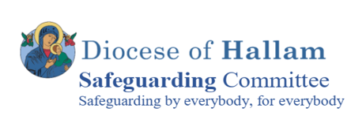

**Thanks are given to the Survivors who have helped with the**

**Creation of today’s Service. We also, on behalf of all Survivors, thank everyone involved with your active participation today.**

For Survivors of Abuse

Tuesday 9th May 2023

Blessed Trinity Catholic Church Parish Hall

22 Willow Court, Northfield Lane,

Wickersley, S66 2HL



**2 Welcome and Introduction Marie O’Donnelly**

I would like to thank you all for coming to this service today, to show that you stand by Survivors of Abuse, and to help the Church in its mission to make atonement, not only for the abuse that Survivors have faced, but for the damage caused by the Churches lack of response and acknowledgement in the past. Before we begin, I want you all to know that this is a safe space. There may be parts or all of this service that affect you deeply. Please take good self-care and if you need to leave at any point to take a moment to yourself, then please do this. If you need to talk to somebody after the service, please do ask to speak to somebody in confidence. You will all have a copy of the Survivors Guide, a short leaflet which explains how the church will support and respond to Survivors. My contact details are provided on the back of the leaflet and there is also a list of National and Local Support Agencies that are available to contact.

**I now invite Bishop Ralph, to kindly begin your Service with a Prayer.**

**Prayer for Healing & Reconciliation**

Praise to you Father of our Lord Jesus Christ,

The source of all consolation and hope.

Be the refuge and guardian of all who suffer from abuse and violence.

Comfort them and send healing

for their wounds of the body, soul and spirit.

Help us all and make us one with you in your love for justice

as we deepen our respect for the dignity of every human life.

Giver of peace, make us one in celebrating

Your praise, both now and forever.

We ask this through Christ our Lord.

**Amen**

**3 A Word from Francis, Our Pope – Marie O’Donnelly**

“Looking back to the past, no effort to beg pardon and to seek to repair the harm done will ever be sufficient. Looking ahead to the future, no effort must be spared to create a culture able to prevent such situations from happening, but also to prevent the possibility of their being covered up and perpetuated. The pain of the victims and their families is also our pain … Today we are challenged as People of God to take on the pain of our brothers and sisters wounded in their flesh and their spirit...we want solidarity to become our way of forging present and future history … ” Pope Francis 1

**Why we are here**

Something so devastating has happened among us in the Church - the abuse of children and vulnerable adults, by those held in honoured positions of authority, trust and sacred calling. How can we face and somehow share this pain held in the bodies and spirits of those deeply impacted by their wounds? How can we open ourselves in real solidarity with victims and survivors, families and communities, and allow the mystery of our faith to change us and forge a way through healing and restoration? In this context, the journey from the past, into the present and towards the future will be unique for every person, depending on their experience, and how the abuse has impacted them. The landscapes and routes are different, with different starting points. Every journey takes courage, and needs compassionate companions– peer support, trusted family and friends, caring community members, clergy and lay. It is daunting, and yet compelling, for ‘no effort must be spared’ to accompany the pain of those impacted by abuse.





**4. Intercessions - Amanda Ryall - Trustee**

|  |
| --- |
| God of Love, I hold in my heart and place into your hands,  those who have experienced abuse,  especially those whose abuse was associated with the Church,  that should have cared and nurtured them.  I pray for those for whom the abuse is current,  for those for whom it is a memory that still brings fear and shame,  for those looking ahead to a more hopeful future.  I pray also for their families who may not have known or realised  the extent and effect of the abuse on their loved one and who are left feeling betrayed and powerless to help.  **Lord In Your Mercy, Hear our Prayer**  God of Love, I hold in my heart and place into your hands,  those who support survivors: Safeguarding coordinators and counsellors, And all who create a safe space in which they can find healing.  I pray for those communities who have been affected  by revelations of abuse, whether current or in the past:  for the sense of disbelief, of betrayal, of deep sorrow, or shame  that this happened in their midst.  I pray for members of the clergy and pastoral workers whose trust in someone they respected and worked with has been broken  **Lord In Your Mercy, Hear our Prayer** |
|  |

**6 . Survivors Testimony**

You will now hear a testimony that has been written by a Survivor of Abuse.

Please take the time to reflect on the story that you hear.

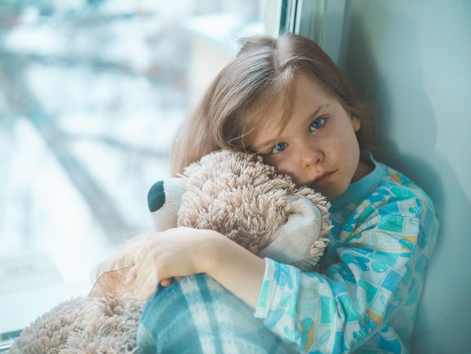

What stays with you having heard the voice of this survivor speaking about their journey? What do you think was helpful to the Survivor? What do you think hurt for the Survivor?

____________________________________________________________

_________________________________________________________________

_________________________________________________________________

_________________________________________________________________

_________________________________________________________________

____________________________________________________________

_________________________________________________________________

_________________________________________________________________

_________________________________________________________________

_________________________________________________________________

**5. Intercessions Ctd – Shauna Hilton Parish Safeguarding Representative**

|  |
| --- |
| God of Love, I hold in my heart and place into your hands,  those who want to leave the Church because of the abuse crisis,  and for those who already have.  I pray for those who have lost hope that things will or can change.  I pray for those who deny that abuse has happened within the Church,  who cannot believe that people who have done much good,  can also have caused such harm.  I pray for those who acknowledge that it has happened  but who just want to move on without facing the need for reconciliation  and healing of those who suffered the abuse. |

**Lord In Your Mercy, Hear our Prayer**

God of Love, I hold in my heart and place into your hands

those who have given way to temptation.

I pray that they acknowledge the harm that they have caused

to our children and vulnerable adults

and that they accept justice and the help they need

to ensure that they cause no more harm.

I pray for those who investigate allegations of abuse,

those who gather evidence in order to bring justice

to those who have been harmed,

those whose work behind the scenes and

helps to change the culture in our society and,

especially, in our Church and who work to create hope for the future.

**Lord In Your Mercy, Hear our Prayer**



**8. We Will Now Pledge our Support To Survivors of Abuse**

We now ask you to join us to pledge your support to Survivors of Abuse, please write your name on the back of your hanging heart, then taking it in turns in rows, please come to the front to hang your heart on our Tree of Support before returning to your seats.

**Let us Join Together in Song as we do this.**

***Do not be afraid, for I have redeemed you.***

***I have called you by your name. You are mine***

1. When you walk through the waters I’ll be with you.

You will never sink beneath the waves.

2. When the fire is burning all around you

you will never be consumed by the flames.

3. When the fear of loneliness is looming,

then remember I am at your side.

4. When you dwell in the exile of the stranger,

remember you are precious in my eyes.

5. You are mine, O my child, I am your Father

and I love you with a perfect love.

**7 Scriptural Reflection**

**A Survivor has contributed this Psalm and reflection to be read out today**

**Psalm 121 A Song of Ascent to Jerusalem**

I lift up my eyes to the mountains:

from where shall come my help?

My help shall come from the Lord

who made heaven and earth.

May he never allow you to stumble!

Let him sleep not, your guard.

No, he sleeps not nor slumbers,

Israel’s guard.

The Lord is your guard and your shade;

at your right side he stands.

By day the sun shall not smite you

nor the moon in the night.

The Lord will guard you from evil,

he will guard your soul.

The Lord will guard your going and coming

both now and for ever.

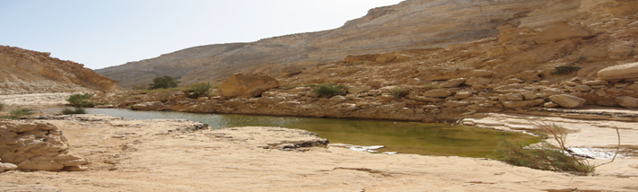

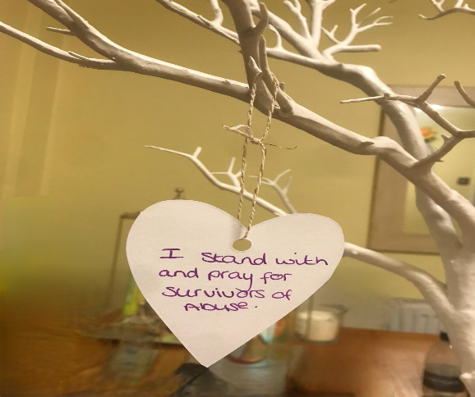



**10 A Word from Bishop Ralph and Msgr Desmond Sexton-Vicar General**

**Our Commitment to Survivors**

The Diocese of Hallam is committed to those who report having been harmed by abuse to shape an effective Safeguarding Service. We value the unique knowledge and wisdom that can only come from listening to those who have been harmed by abuse.

**Our commitment**is for those who have been harmed by abuse to be accepted and valued as contributing members of the Church, and to have a sense of belonging to the Catholic Church community.

**Care and support** of those who have been harmed by abuse with whom we build these relationships will be foremost, ensuring that any engagement does not create anxiety or the possibility of re-traumatisation for the individual involved. Positive engagement can be part of the healing process for the person who has been harmed by abuse and care will be taken to ensure that those we speak with are not adversely affected.

**Confidentiality and privacy**will be respected. Where there is information or feedback from those who have been harmed by abuse to be shared with Senior Church Leaders and Trustees, the nature and content will be agreed. Those who disclose abuse or make new disclosures will be listened to and treated with respect, compassion and dignity. Where new disclosures are made, these will be handled appropriately and in accordance with national safeguarding policy and procedures which include the reporting of abusers to statutory authorities.

To help embed our commitment to Survivors, a Listening Guide created by the Isaiah Journey Working Group has been provided for you to take away. There is lots of information that will support you to listen in a trauma informed way to those hurt by abuse and in particular, Listening as a Person of Faith, to someone impacted by Abuse in the Church.

Please take the time to read this and share amongst members of your Parish so that we can be a Church of People who listen, to do no harm…….



**11 A Word from our Diocesan Counselling Service – Bernie Ware**

**What is Counselling?**

* Counselling offers a safe and non-judgemental environment
* Counselling can enable you to feel less isolated, improve your self-esteem and confidence
* Counselling can be life changing
* Counselling is confidential-there are some exceptions which are discussed with you at the first counselling session
* All our counsellors are qualified Psychotherapists and are registered with a national body
* They receive independent supervision as well as professional supervision from within Caritas
* They are all DBS registered and receive a robust induction that includes Safeguarding Training-this training is updated annually

**Who can access our service ?**

* Schools- to support students and staff
* Carmel Care and St Wilfrid’s-supporting clients who attend
* Mission Hub-working with 18-35 yr. olds
* Community -any adult across South Yorkshire who feels they need support
* Clergy-throughout the Diocese of Hallam as well as supporting clergy and religious throughout the country (via John Paul 2nd Clergy Counselling Directory)
* Relationship Counselling
* Family Support-Parenting advice and counselling

The Diocesan Counselling Service has supported many Survivors of Abuse, from Domestic Abuse Survivors, those living with neglect, on to those harmed by members of the Church through Sexual, Psychological and Physical Abuse. Services are also provided to those who self-abuse through addiction, self- harm, or have suicidal thoughts.

The Service recognises the difficulties faced by those who have experienced abuse and have the primary aim to support healing and building resiliency for those who are seeking healing. Any disclosure of abuse will be followed up with Signposting for Support, including use of the Diocesan Counselling Service.

You will be listened to with compassion and caring.

If you would like to access the service please contact via:

Telephone : 0114 256 6401 Mobile: 07980406198

Email: bware@hallam-diocese.com

**In our Closing Prayer, we ask that the Lord be ever present,**

**so that we may listen.**

Holy Mystery of GOD, may I be open to hearing YOU in the many ways YOU speak – may I see YOUR face and hear YOUR voice in the person I am listening to:

In the silence of the stars,

In the quiet of the hills,

In the heaving of the sea,

Speak Lord.

In the stillness of this room,

In the calming of my mind,

In the longing of my heart,

Speak Lord.

In the voice of a friend,

In the chatter of a child,

In the words of a stranger,

Speak Lord

In the opening of a book,

In the looking at a film,

In the listening to music,

Speak Lord, for your servant listens.

**Sarah Dean will now perform a song that has been specially selected for our Service Today.**

**Please feel free to join in (the lyrics are on the sheet provided) and light your tea lights as we listen to the song and hold loving thoughts in our hearts, for those who have been hurt by abuse.**

**Refreshments will now be served but please feel free to take some time to reflect on today’s service.**