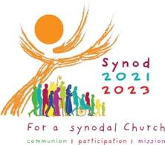
Synod Listening Group Response Record Sheet Date:
Parish:
Number in Group:
Reason for Group being together:

Anything else about the nature of the group?

Synod questions for prayer, listening and discernment:
A synodal Church, in announcing the Gospel, journeys together.
- How is this “journeying together” happening in your parish?
- How is the Holy Spirit inviting your parish community to grow in journeying together?
Themes:

Summary:

