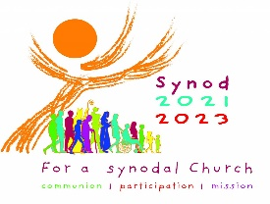
Quick guide to responding to allegations of abuse or concerns about children and adults at risk

All concerns must be brought to the Safeguarding Representative, who in turn will contact the diocesan
Safeguarding Coordinator. Never delay taking action. If you are unable to contact the Safeguarding Representative and/or Coordinator you can contact the Catholic Safeguarding Advisory Service (CSAS) if you require advice.
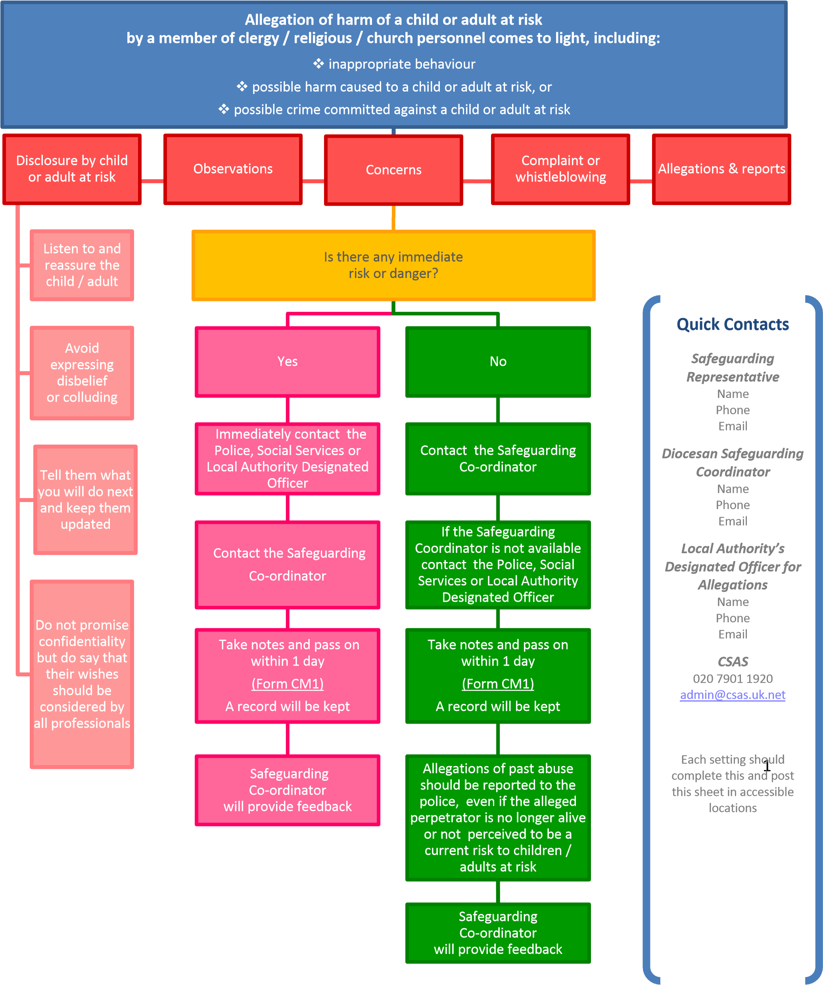
Please identify the Safeguarding Representative for your Parish
Marie O’Donnelly
modonnelly@hallam-diocese.com
07909117964

