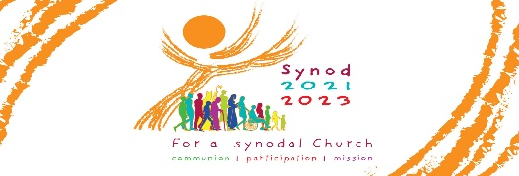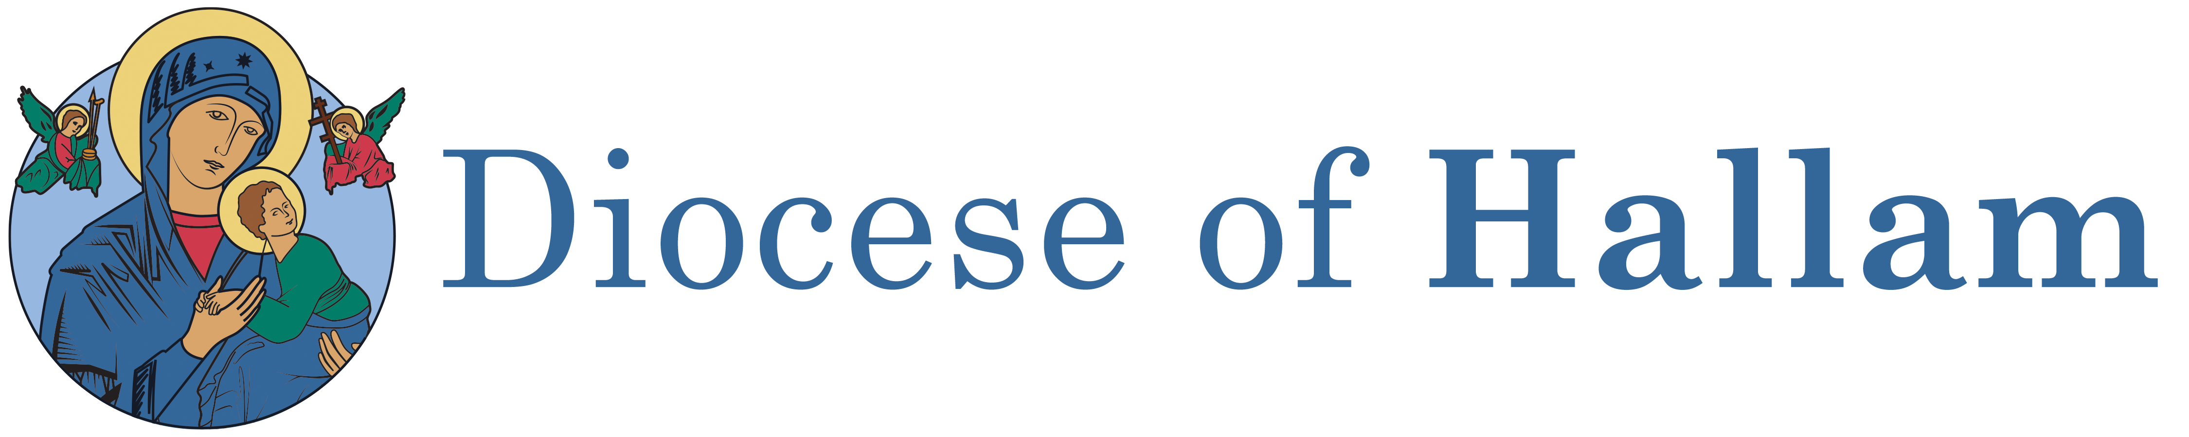

HALLAM TRUSTEE SAFEGUARDING COMMITTEE

Are you in active ministry within your parish?
Do you have an up to date DBS for your role?

As part of our commitment to ensure the safe recruitment of all volunteers within the church, DBS applications are open to anyone who needs to renew or apply for their Hallam Diocese DBS. As a beacon of good practice, in this Diocese all volunteers in ministry roles have a DBS renewal every three years.

DBS checks are required for those who have a direct role in working with children, young people or adults who may be vulnerable (either in a group or one to one basis). Typical roles that are eligible for a DBS are:
Altar Server/Altar Server Chaperone (over 18 years of age)
CAFOD volunteers
Catechist (children and/or adults)
Children’s Liturgists
Choir Leaders (if unsupervised)
Extraordinary Ministers of Holy Communion (home visitors only)
Hospital Visitors/Parish Visitors including Synod Visitors
Sacristan
Parish Safeguarding Representatives
SVP
Youth Ministry Groups/Youth Workers

Other roles may be subject to a DBS depending on the nature of the role. Please contact the Safeguarding Office if you are not sure whether you are eligible for a DBS.
Tel: 0114 2566453 Email: jpearson@hallam-diocese.com

Before completing DBS paper work you will be required to produce original ID documents such as a driving licence, passport, or birth certificate. Proof of address is also required such as a recent bank statement, council tax statement or utility bill (not a mobile bill) issued within the last 3 months.

Evidence of change of name (where applicable) is also required in the form of a marriage certificate or deed poll certificate. You are also required to enter your national insurance number on the application form.

