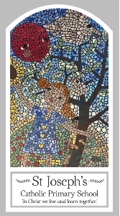
Year Six
Knowledge Organiser
Universal Church - World
Topic 9: Common Good
Key Words
Word | Definition
justice
injustice
respect
solidarity
difference
Social Justice
Common good
dignity
Catholic Social Teaching
Scripture
Micah 6: 8
Matthew 5: 1-17 God’s Story 3 page 82
Matthew 25: 31-40
Luke 4: 14-22

Big Question
How can we work together to make a just and fair world?
My first thoughts:

What will I learn?
- To make links to show how their feelings and beliefs about being treated fairly/unfairly, justly/unjustly affect their behaviour and that of others and be able to compare their own and other people’s ideas about questions that are difficult to answer regarding injustice and unfairness.
- To make links between micah, matthew 25, the beatitudes and beliefs and give reasons for certain actions by believers, in working for justice and the common good.
- To show how their own and other’s decisions to act justly and fairly/unjustly and unfairly are informed by beliefs and values and be able to describe and show understanding of religious sources, beliefs, ideas, feelings and experiences around the common good, making links between them.
- To show understanding of how religious belief in justice and of the common good of all shapes life and be able to engage with and respond to big questions around justice and the common good in the light of religious teaching.
- To explain what beliefs and values inspire and influence them and others to act justly and fairly and be able to identify sources of religious belief and explain how religious beliefs including catholic social teaching about the common good arise. They will be able to demonstrate how religious beliefs and catholic social teaching give some explanation of the purpose and meaning of life.

