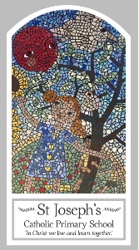
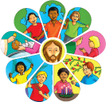
Year Six
Knowledge Organiser
Reconciliation – Inter-Relating
Topic 8: Healing
Key Words
Word | Definition
care
sickness
hospice
Compassion
Sacrament
anointing
sin
forgiveness
parable
Lourdes
responsibility
Scripture
Mark 6: 13
Luke 18: 35-43 and God’s Story 3 page 98
Luke 10: 30-37
James 5: 14-15
Big Question
Who needs healing?
My first thoughts:

What will I learn?
- To make links to show how feelings and beliefs about sickness and care affects their behaviour and that of others.
- To compare their own and other people’s ideas about questions concerning serious illness and bereavement which are difficult to answer.
- To use a developing religious vocabulary to give reasons for the religious actions and symbols used in the sacrament of the anointing of the sick.
- To give reasons why christians care for the sick and the needy.
- To engage and respond to questions of the experience of sickness and healing in the light of religious teaching.
- To show how their own and others’ decisions about care and compassion towards the sick are informed by beliefs and values.
- To describe and show understanding of religious sources, beliefs, ideas, feelings and experiences concerning the sacrament of the anointing of the sick and make links between them.
- To use religious terms to show an understanding of the different liturgies connected to the sacraments offered to the sick and dying.
- To show understanding of how religious belief shapes life, and that caring for those in need is a christian responsibility.

