Knowledge Organiser
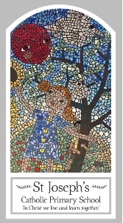
Year Six
Local Church – Community
Topic 4: Sources
Key Words
Word | Definition
poetry
prose
history
information
stories
Bible
Old Testament
genre
Scripture
Romans 15: 4-6
Bible
Bible references, genre, context

Big Question
Are books enriching?
My first thoughts:

What will I learn?
- To compare their own and other people’s ideas about how books enrich our lives and take us beyond ourselves and realise these questions are difficult to answer.
- To make links between scripture and Christian beliefs.
- To give reasons for when and how Christians use the bible.
- To describe and show an understanding of the bible, the beliefs, ideas, feelings and experiences of the Christian and make links between them.
- To show understanding of how the bible shapes the lives of Christians.
- To engage with the question, ‘what is god like?’ or ‘what is Jesus like?’ in the light of religious teaching.
- To show how their own and others’ decisions are informed by beliefs and values which may be influenced by what they have read.

