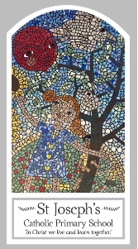
Year Six
Knowledge Organiser
Domestic Church – Family
Topic 1: Loving
Key Words
Word | Definition
unconditional
forgiveness
mercy
prodigal
parable
reconciliation
Scripture
Isaiah 40: 1-5,9-11,28-31 – God’s Story 3 page 62
Psalms 23 and 136 – God’s Story 3 pages 46-47
Luke 15: 11-32 – God’s Story 3 page 102
Matthew 5: 1-12, 44-48
John 15: 9-14
Ephesians 4:26, 31-32
Titus 3: 4-8

Big Question
Do you have to earn love?
My first thoughts:

What will I learn?
- To make links between the story of the prodigal son and the Christian’s belief in God’s forgiveness.
- To give reasons for a Christian’s love and care.
- To describe and show understanding of the scripture, beliefs, feelings and experience of God’s unconditional love and make links between them.
- To be able to show understanding of how religious belief in God’s unconditional love shapes life.
- To be able to engage with and respond to questions about loving, in the light of religious teaching.

