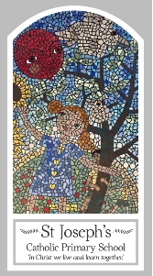
Year Five
Knowledge Organiser
Pentecost - Serving
Topic 7: Transformation
Key Words
Word | Definition
transformation
Holy Spirit
change
gifts
Fruits of the Spirit
Transform
Energy
Wind
fire
Scripture
Galatians : 5: 16-17, 22-23 – God’s Story 3 page 144
Luke 24: 13-35 – God’s Story 3 pages 128-129
Acts 2: 32-39, 41-42
Acts 22: 6-16
Romans 8: 14-17

Big Question
How can energy transform?
My first thoughts:

What will I learn?
- To make links to show how feelings and beliefs about the use of transforming energy affects their behaviour and that of others.
- To compare their own and other people’s ideas about questions that are difficult to answer about transforming energy and its uses.
- To give reasons for the actions of cleopas on the road to emmaus.
- To use a developing religious vocabulary to give reasons for religious actions and symbols connected with pentecost.
- To give reasons for certain actions of christians inspired by the holy spirit.
- Some children will be able to make links between scripture and god’s gift of the holy spirit and forgiveness.

- To show understanding of how their own and others’ decisions about the use of transforming energy are informed by belief and values.
- To describe and show understanding of religious sources, beliefs, ideas, feelings and experiences, concerning the conversation of paul, making links between them.
- To show understanding of the transforming power of the holy spirit and how it shapes the lives of christians.
- To engage with and respond to questions about how the belief in the transforming power of the spirit and the message expressed in paul’s letter give meaning and purpose to life.

