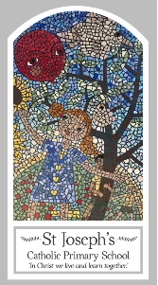
Year Five
Knowledge Organiser
Eucharist – Relating
Topic 5: Memorial Sacrifice
Key Words
Word | Definition
Memories
significant
Memorial sacrifice
Passover
Pesach
host
chalice
Liturgy of the Eucharist
Eucharistic prayer
consecration
adoration
Genuflect
acclamation
Scripture
Exodus 13: 3
Luke 22: 14-20

Big Question
Why do we need memories?
My first thoughts:
What will I learn?
- To compare their own and others’ ideas about what makes a particular memory significant and why words, symbols or actions might evoke it and realise these questions are difficult to answer.
- To make links to show how feelings and beliefs about memories affect their own behaviour and that of others.
- To make links between the passover in exodus, the last supper and belief in the eucharist.
- To use a developing religious vocabulary to give reasons for religious actions and symbols connected to the passover and the celebration of the eucharist.
- To give reasons for why believers follow the example of jesus in his life of sacrifice.
- To show understanding of how their own and others’ decisions about memories are informed by beliefs and values.
- To describe and show understanding of scripture, beliefs, ideas, feelings and experiences about the jewish passover, the last supper and the celebration of eucharist, making links between them.
- To show understanding of how belief in the sacrifice of jesus shapes the lives of christians.
- To engage with and respond to questions of life choices in the light of religious teaching about sacrifice.

