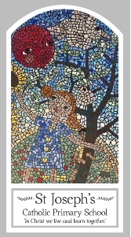
Year Five
Knowledge Organiser
Local Church – Community
Topic 4: Mission- Life Choices
Key Words
Word | Definition
Mission
Bishop
ecumenism
catherdral
diocese
inspirational
Baptism
Christian unity
Gentile
inspired
Scripture
Luke 4: 14-22 – God’s Story 3 page 95
Isaiah 61: 1-2, 10-11 – God’s Story 3 page 65
Luke 8: 1-3 – God’s Story 3 page 99
John 17: 11-12, 20-23 – God’s Story 3 page 109
I Corinthians 12: 12-17, 21, 27
Big Question
Do we all have a mission in life?
My first thoughts:

What will I learn?
- To make links to show how inspirational leaders affect their behaviour and that of others.
- To compare their own and other people’s ideas about questions about what inspires people in their mission and realise that some of these are difficult to answer.
- To make links between how Jesus undertook his mission to share the good news and how each diocese continues that mission and work today.
- To give reasons why people carry out Jesus’ mission in different ways through what they say and do.
- To begin to show an understanding of how their own and others’ decisions in carrying out their mission in communities are informed by beliefs and values.
- To describe and begin to show they understand how dioceses and different christian communities continue to carry out the work and mission of jesus.
- To make links between this and what they have read in scripture.
- To show they understand why christians, because of what they believe, want to share the mission of jesus and do so in different ways.
- To engage and respond to questions of how religious teaching affects life and work within a community and diocese.

