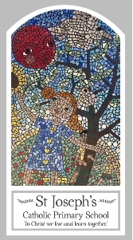
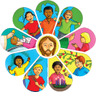
Year Five
Knowledge Organiser
Domestic Church – Family
Topic 1: Ourselves
Key Words
Word | Definition
qualities
talents
unique
gifts
challenge
joys
happiness
responsibility
dignity
image
pacemaker
Scripture
Genesis 1: 26 –28 – God’s Story 3 page 10
Colossians 3: 10 -11 – God’s Story 3 page 147
Colossians 3: 12-17 – God’s Story 3 page 147
Philippians 4: 4-9 – God’s Story 3 page 146
Hosea 11: 1-4 – God’s Story 3 page 67

Big Question
Who am I?
My first thoughts:

What will I learn?
- To be able to make links between the words of Paul and the Christian’s belief in peace.
- To be able to compare their own and other people’s ideas about questions of talents and qualities.
- To be able to give reasons why Christians believe in peace.
- To be able to describe and show an understanding of the scripture, beliefs, feelings and the experience of being made in image and likeness of God.
- To begin to show understanding of how the call to be holy shapes life.

