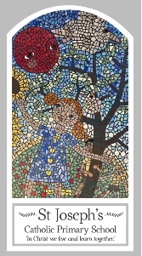
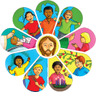
Year Five
Knowledge Organiser
Other Religions - Judaism
Beliefs and Festivals – Pesach

Key Words
Word | Definition
remembering
Passover
seder
Pesach
kosher
Matzah
bitter
herbs
Charoset
Lamb
Shema
mezuzah

Topic
Pesach
My first thoughts:

Look
There are times for remembering

Discover
Pesach
Respect
God cares for his people

Attainment Targets
AT 1 Learning about religion
i Beliefs, teaching & sources
ii celebration and ritual
iii social & moral practices & way of life
AT 2 Learning from religion
i engagements with own & others’ beliefs & values
ii engagement with questions of meaning

