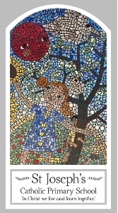
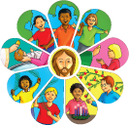
Year Four
Knowledge Organiser
Universal Church - World
Topic 9: God’s People
Key Words
Word | Definition
Communion of Saints
peace
justice
martyr
saint
admire
extraordinary
ordinary
Scripture
1 John 3: 1−3 – God’s Story 3, page 149
Colossians 3: 12−13 God’s Story 3, page 147
1 Corinthians 12: 4−30

Big Question
Why do some people do extraordinary things?
My first thoughts:

What will I learn?
- To ask and respond to questions about their own and others’ experiences and feelings of ordinary people doing extraordinary things and be able to ask questions about what they and others wonder about ordinary people doing extraordinary things and realise that some of these questions are difficult to answer.
- To retell some special stories about religious events and people who show what god is like and will be able to describe some ways in which religion is lived out by different saints.
- To give reasons for certain actions by those people they have studied and be able to make links between scripture and the action and beliefs of followers of god’s way.
- To make links to show how feelings and beliefs affect their behaviour and that of others, using the example of eric or other examples and compare their own and other people’s ideas about the question of what makes a person do extraordinary things and find it is a difficult question to answer.
- To show how their own and others’ decisions about actions in life are informed by beliefs and values and describe and show an understanding of scripture, beliefs, ideas, feelings and experience, making links between them.
- To show understanding of how religious belief has shaped the way some people live out their lives.

