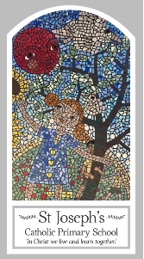
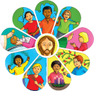
Year Four
Knowledge Organiser
Reconciliation – Inter-Relating
Topic 8: Building Bridges
Key Words
Word | Definition
bridges
Friendship
contrition
Absolution
Sacrament of Reconciliation
Examination of Conscience
sin
penance
confession
Scripture
Colossians 3: 12-15
Matthew 5: 23-24
Luke 15:3-6,7 God’s Story 3 page 104
Mark 12: 28-31 God’s Story 3 page 92
Big Question
Why are bridge builders important in life?
My first thoughts:

What will I learn?
- To ask and respond to questions about their own and others’ experience and feelings about what breaks and what mends a friendship.
- To ask questions about what they and other wonder about how friendships may be restored. To use a developing religious vocabulary to describe some religious actions and symbols used in the sacrament of reconciliation.
- To use religious words and phrases to give reasons for some religious actions and symbols used in the sacrament of reconciliation.
- To make links to show how feelings and beliefs affect their behaviour and that of others in respect to maintaining friendship.
- To compare their own and other people’s ideas about questions of building and maintaining friendship and realise that these questions are difficult to answer.
- To make links to show how feelings and beliefs about reconciliation affect their behaviour and that of others.
- To give reasons why believers ask forgiveness of others and forgive those who have hurt them.

