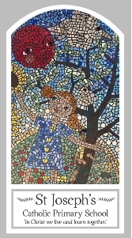
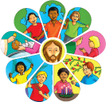
Year Four
Knowledge Organiser
Pentecost - Serving
Topic 7: New Life
Key Words
Word | Definition
Life
Good news
Resurrection
Pentecost
Holy spirit
fellowship
Scripture
Acts 4 : 1-26 – God’s Story 3 page 136
2 Corinthians 6: 3-10 – God’s Story 3 page 144
Acts 8: 26-30, 34-38 God’s Story 3 pages 138-139

Big Question
What’s so important about new life?
My first thoughts:

What will I learn?
- To ask and respond to questions about their own and others’ experiences of good news bringing life.
- To ask questions about what they and others wonder about how good news brings life and happiness.
- To retell some special stories about the religious events and people connected with pentecost.
- To use religious words and phrases to describe the events of pentecost.
- To describe some ways in which the apostles spread the good news through the power of the holy spirit.
- To make links to show how feelings of sadness and joy and the belief in the goodness of others, affects their own and others’ behaviour.
- To compare their own and other people’s ideas about how good news brings life.
- To give reasons why the apostles spread the good news and the reasons for the actions of peter, john and paul.
- To make links between the pentecost story and the christian belief in the new life of the easter message through the power of the holy spirit.

