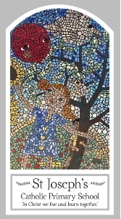
Year Four
Knowledge Organiser
Eucharist – Relating
Topic 5: Giving and Receiving
Key Words
Word | Definition
Communion
community
giving
receiving
Liturgy of the Word
Penitential Act
Lamb of God
Concluding Rite
Sign of Peace
Introductory Rite
Eucharist
Communion Rite
Scripture
Matthew 5: 45-48 God’s Story 3 page 84
(teachers’ page 157)
1 Corinthians 11: 24-27 – God’s Story 3 page 143
(teachers’ page 159)
Romans 12: 8-11 God’s Story 3 page 141

Big Question
What’s more important giving or receiving?
My first thoughts:

What will I learn?
- To ask and respond to their own and others’ experiences and feelings about giving and receiving.
- To ask questions about what they and others wonder about giving and receiving every day and realise that some of these questions are difficult to answer.
- To describe what happens during the Introductory Rite.
- To describe what a person might do if they follow Jesus’ advice.
- To describe ways in which peace is lived out by believers.
- To make links to show how feelings and beliefs about giving and receiving affects their own behaviour and that of others.
- To compare their own and other people’s ideas about questions of giving and receiving that are difficult to answer.
- To make links between scripture and an understanding of the Eucharist.
- To use a developing religious vocabulary to give reasons for religious actions and symbols used in the celebration of the Eucharist.
- To give reasons why Christians attend the celebration of the Eucharist.

