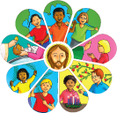

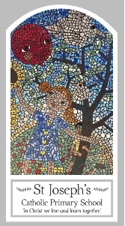
Year Four
Knowledge Organiser
Local Church – Community
Topic 4: Community
Key Words
Word | Definition
deanery
community
commitment
responsibility
parish
laity
ministries
Extraordinary Ministers
service
funeral rites
pastoral area
Scripture
Romans 12: 8-11– God’s Story 3 page 141
(teachers’ notes page 159)
Mark 3: 13-19 – God’s Story 3 page 90
(teachers’ notes page 157)
Acts 6: 2-13; 7: 57-60 – God’s Story 3 page 137

Big Question
What makes a ‘community’?
My first thoughts:

What will I learn?
- To ask and respond to questions about their own and others’ experiences of being part of a community.
- To ask questions about what they and other wonder about the responsibility and commitment of belonging to a community and realise that some of these questions are difficult to answer.
- To retell the story of the call of the apostles.
- To describe some of the advice st. Paul gives us about being loving members of a community.
- To use religious words and phrases to describe the actions and symbols within a funeral mass.
- To describe some ways in which some people serve their parish community.
- To make links to show how feelings and beliefs affect their commitment to community and that of others.
- To make links between the call of the apostles and god’s call to people to serve him today.
- To use a developing religious vocabulary to give reasons for the actions and symbols used within a funeral mass.
- To give reasons why people give service to the parish community through various ministries.

