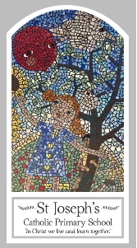
Year Four
Knowledge Organiser
Advent/Christmas – Loving
Topic 3: Gift

Key Words
Word | Definition
gift
friendship
loyalty
commitment
rejoice
peace
God’s plan
Scripture
Isaiah 40: 9-11 God’s Story 3 page 62
Matthew 2: 1-12, 16-18 God’s Story 3 page 76
(God’s Story 3 teachers’ notes page 156)
Ephesians 1: 3-6 God’s Story 3 page 145
1 John 4: 4, 9-12
Philippians 4: 4-9

Big Question
What’s so special about gifts?
My first thoughts:

What will I learn?
- To be able to ask and respond to questions about what is important in friendship.
- To be able to ask questions about what they and others wonder about the gift of love and friendship and realise that some of these questions are difficult to answer.
- To be able to make links to show how feelings and beliefs affect their behaviour and that of others in relation to the gift of love and friendship.
- To begin to compare their own and other people’s ideas about the gift of love and friendship and realise that these questions are difficult to answer.
- To be able to retell the story of the birth of Jesus and the visit of the Wise Men.
- To be able to use religious words and phrases to describe some of the religious actions and symbols which help Christians prepare during Advent for the coming of Jesus at Christmas.
- To be able to make links between scripture texts and the belief that God sent Jesus to earth as the long-awaited Messiah.
- To be able use a developing religious vocabulary to give reasons for the actions and symbols connected with the liturgical season of Advent and Christmas.

