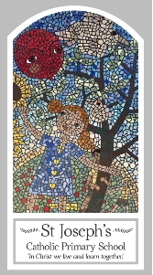
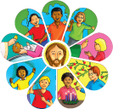
Year Four
Knowledge Organiser
Domestic Church – Family
Topic 1: People
Key Words
Word | Definition
Chosen
People
Siblings
Relations
Ancestors
Old testament
Roots
Family tree
Genealogy
Nomad
Nomadic
Scripture
Matthew 1: 1-17 God’s Story 3 page 69
Mt 2: 13-15, 19-23, Lk 2: 40-51, Mk 1: 14-20
Genesis 12: 1-8, 18 God’s Story 3 page 12
Genesis 21: 1-7 God’s Story 3 page 12
Genesis 25: 20-27 God’s Story 3 page 14
Genesis 35: 9-15, 23-26 God’s Story 3 page 14
Genesis God’s Story 3 pages 15-17
Ruth 1: 2-7, 16, 17 God’s Story 3 page 37
1 Kings 1, 2, 4 God’s Story 3 page 36

Big Question
Where do I come from?
My first thoughts:

What will I learn?
- To be able to retell some of the stories from scripture about Jesus’ family.
- To be able to describe some ways in which characters in the Bible lived out their lives.
- To be able to make links between these stories and what people believe about God and Jesus.
- To be able to give reasons for certain actions by believers such as Ruth.
- To be able to describe and show understanding of the roots of Jesus’ human family.
- To be able to describe and show understanding of what Christians believe about how God leads and guides people.

