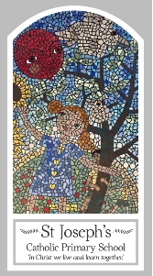
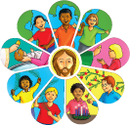
Year Four
Knowledge Organiser
Other Religions - Judaism
Holy Books - The Torah

Key Words
Word | Definition
Books
Tenakh
Sefer
Torah
Hebrew
scroll
scribe
yad
Ark
Bar/bat Mitzvah

Topic
The Torah
My first thoughts:

Look
Books are important

Discover
The Torah
Respect
The importance of the Torah

Attainment Targets
AT 1 Learning about religion
i Beliefs, teaching & sources
ii celebration and ritual
iii social & moral practices & way of life
AT 2 Learning from religion
i engagements with own & others’ beliefs & values
ii engagement with questions of meaning

