4

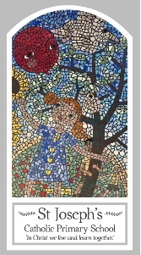
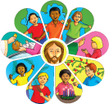
Year Three
Knowledge Organiser
Universal Church - World
Topic 9: Special Places
Key Words
Word | Definition
special
holy
place
pilgrim
pilgrimage
universal
temple
Nazareth
Scripture
Luke 2: 11 Bethlehem Matthew 2: 23 Nazareth
Luke 2: 41, 46 Jerusalem
Mark 1: 9, Baptism in the Jordan Matthew 5: 1-2 Sermon on the mount Psalm 24: 1
Romans 5: 5

Big Question
What makes a place special?
My first thoughts:

What will I learn?
- To ask and respond to questions about their own and others’ experiences of and feelings about special places and ask questions about what they and others wonder about special places and realise that some of these questions are difficult to answer.
- To retell the stories about special places for jesus and describe some ways in which religion is lived out by christians in terms of pilgrimage and worship
- To make links to show how feelings and beliefs about special places affect their behaviour and that of others and compare their own and others’ ideas about questions relating to why some places are special that are difficult to answer.
- To use a developing religious vocabulary to give reasons why christians go on pilgrimage and be able to give reasons why christians should care about the world.

