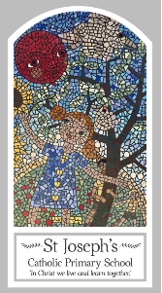
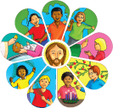
Year Three
Knowledge Organiser
Reconciliation – Inter-Relating
Topic 8: Choices
Key Words
Word | Definition
Reconciliation
Confession
Conscience
Sorrow
Penance
Sin
Choice
Consequences
Repentance
Penitent
Absolution
grace
Scripture
Matthew 21: 28-31
1 Thessalonians 5: 12-18 God’s Story 3 page 148
Luke 15: 11-32 God’s Story 3 page 102
Big Question
What helps me to choose well?
My first thoughts:

What will I learn?
- To ask and respond to questions about their own and others’ experiences of making choices. To ask questions about what they and others wonder about how choices are made and realise that some of these questions are difficult to answer.
- To retell the stories of the two sons and the prodigal son.
- To use religious words and phrases to describe saying sorry and asking for fogiveness. To describe the sacrament of reconciliation.
- To describe a simple examination of conscience and to write or say a sorry prayer. To describe some ways in which followers of jesus live.
- To make links to show how feelings and beliefs affect their and others’ decisions about choices and their consequences.
- To compare their own and other people’s ideas about questions of choices and their consequences and realise that these questions are difficult to answer.
- To make links between religious stories and the belief in a loving and forgiving god. To use a developing religious vocabulary to begin to give reasons for what happens in the sacrament of reconciliation. To give reasons why particular christians make good choices and follow jesus.

