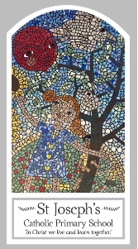
Year Three
Knowledge Organiser
Pentecost - Serving
Topic 7: Gifts of the Holy Spirit
Key Words
Word | Definition
fire
warmth
wind
energy
power
gifts
Holy Spirit
Rosary
Glorious Mysteries
Pentecost
Scripture
Matthew 28: 1-10 God’s Story 3 page 126
John 16: 5-7
1 Corinthians 12: 4-8, 11
Acts 1: 6-11 God’s Story 3 page 132
Acts 2: 1-18, 43, God’s Story 3 page 132
Isaiah 11: 2

Big Question
What is the use of energy?
My first thoughts:

What will I learn?
- To ask and respond to questions about their own and others’ experiences and feelings about the power of fire and wind and how this energy can be used for good.
- To ask questions about what they and others’ wonder about the power of wind and fire and realise that some of these questions are difficult to answer.
- To retell the story of the ascension and the coming of the holy spirit at pentecost.
- Use religious words and phrases to describe what happened to the apostles at pentecost, what they saw and felt.
- To describe some ways in which christians live when they use the energy and gifts of the holy spirit.
- To compare their own and other people’s ideas about questions that are difficult to answer about the best use of the power of wind and fire.
- To make links between the pentecost story and christian belief in the power of the holy spirit.
- To give reasons for the love christians show because they are inspired by the holy spirit.

