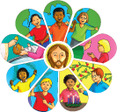

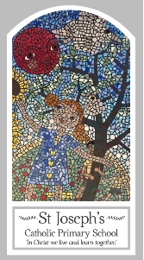
Year Three
Knowledge Organiser
Local Church – Community
Topic 4: Journeys
Key Words
Word | Definition
calendar
seasons
journey
liturgical
Ordinary time
Feast day
Our Lady
Scripture
Psalm 84 – God’s Story 3 page 42
Psalm 118 – 19-20, 26-29 God’s Story 3 page 43
Psalm 122: 1-9 – God’s Story 3 page 42

Big Question
Is life a journey?
My first thoughts:

What will I learn?
- to ask and respond to questions about their own and others’ experiences and feelings about the events which mark the year or the season.
- to ask questions about what they and others wonder about how we help one another on the journey through the year.
- to retell some of the stories of the Mysteries of the Rosary or the special feasts of the year.
- to use religious words and phrases to describe the liturgical year and how it is composed of seasons and feasts days.
- to describe how some prayer leads to good actions.
- to make links to show how feelings and beliefs affect how they and others behave in their life journey and what is important to them.
- to make links between some scripture and what Christians believe.
- to use a developing religious vocabulary to begin to give reasons why Catholics celebrate certain feasts of the year and the reasons for the actions and symbols used.

