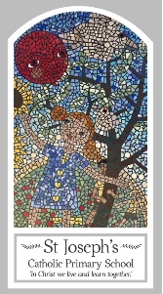
Year Three
Knowledge Organiser
Advent/Christmas – Loving
Topic 3: Visitors

Key Words
Word | Definition
Joys
demands
visitors
Advent
Nativity
Annunciation
The Visitation
Isaiah
Messiah
Magnificat
Joyful Mysteries
Scripture
Isaiah 11: 1
Isaiah 40: 3-5 Church’s Story 3 page 89
Romans 13:9b-13a
Luke 1: 26-31, 38 -58 God’s Story 3 pages 71-72
Luke 2: 1-20 – God’s Story 3 pages 74-75
Matthew 2: 1-12, 16-18, – God’s Story 3 page 76
(God’s Story 3 Teachers’ notes pages 156-7)

Big Question
Are visitors always welcome?
My first thoughts:

What will I learn?
- To be able to ask and respond to questions about their own and others’ experiences and feelings about visitors.
- To be able to ask questions about what they and others wonder about the joys and demands of visitors and why they might feel like that and realise that these questions are difficult to answer.
- To be able make links to show how feelings and beliefs affect how they prepare for and receive visitors.
- To be able to retell the stories of the events surrounding the birth of Jesus.
- To be able to describe how Christians use the time of Advent to reflect on their lives in preparation for coming of Jesus.
- To be able to make links between the Scripture they have explored and Advent as a season of getting ready for the coming of Jesus.
- To be able to give reasons for some of the religious actions of Christians during Advent/Christmas to prepare for the coming of Jesus.

