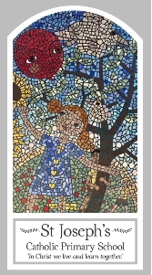
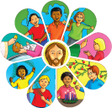
Year Three
Knowledge Organiser
Baptism/Confirmation – Belonging
Topic 2: Promises
Key Words
Word | Definition
Promises
rules
actions
symbols
rite
Sacrament
commitment
faith
Welcome
Church
Ceremonies
Chrism
Anointing
Trinity
Scripture
Jeremiah 31: 3
Mark 1: 9-11

Big Question
Why make promises?
My first thoughts:

What will I learn?
- To ask and respond to questions about promises.
- To ask questions about what you and others wonder about why people make promises.
- To make links between their actions and the promises made.
- To retell the story of the Baptism of Jesus.
- To describe the actions and symbols used at Baptism.
- To give reasons for the actions and symbols used at Baptism.
- To give reasons for the promises made at Baptism.
- To give reasons how and why Christians live as followers of the Light of Christ.

