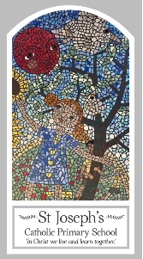
Year Three
Knowledge Organiser
Domestic Church – Family
Topic 1: Homes
Key Words
Word | Definition
Home
Love
Family
Difference
Respect
Joys
Sorrows
Community
Family
Scripture
Romans 12: 8-13 – God’s Story 3 page 141
(Teachers notes page 159)
Ephesians 5: 1-9; and 6: 1-4.
Luke 2: 39-40
John 13:34-35 – God’s Story 3 page 108 (Teachers notes page 158)
Col 3:12-17 God’s Story 3 page 147

Big Question
What makes a house a home?
My first thoughts:

What will I learn?
- To be able to retell some of the advice offered by Paul in his letters about living together as a family and the life of the Holy Family.
- To be able to describe some ways Christians live as people chosen by God.
- To be able to ask questions about what you and others wonder about how God is always with us, and realise that this is a difficult question to answer.
- To be able to make links between some scripture you have studied and the belief that God can make a difference in everyday life through God’s unchanging love.
- To give reasons why Christians should try to love others.
- To compare my own and others’ ideas about what you and others wonder about how God is always with us, and realise that some questions are difficult to answer.

