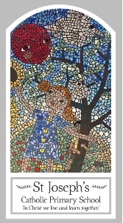
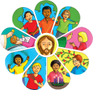
Year Three
Knowledge Organiser
Other Religions - Judaism
Places for Worship – The Synagogue

Key Words
Word | Definition
worship
synagogue
shul
rabbi
Shabbat
Sefer
Torah
Ark
bimah
kippah
tallit
prayer
shawl
kiddush

Topic
The synagogue
My first thoughts:

Look
There are special places

Discover
The synagogue
Respect
The importance of the synagogue

Attainment Targets
AT 1 Learning about religion
i Beliefs, teaching & sources
ii celebration and ritual
iii social & moral practices & way of life
AT 2 Learning from religion
i engagements with own & others’ beliefs & values
ii engagement with questions of meaning

