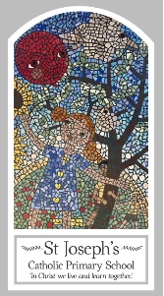
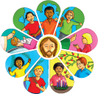
Year Two
Knowledge Organiser
Reconciliation – Inter-Relating
Topic 8: Rules
Key Words
Word | Definition
rules
care
safe
sorry
forgive
right
wrong
Make up
choices
sin
consequences
Examination of conscience
Scripture
John 15: 12
Colossians 3: 10-17 God’s Story 2 page 87
(Notes page 101 )
Matthew 18: 21-22 God’s Story 2 page 65
(Notes page 99 )

Big Question
Do we need rules?
My first thoughts:

What will I learn?
- To talk about their own experience and feelings about rules in their life.
- To say what they wonder about the importance of keeping rules for themselves and for others.
- To recognise the story of Peter asking Jesus about forgiveness as a religious story.
- To recognise some religious words and signs that Christians use to express sorrow and forgiveness.
- To recognise that people say sorry and ask forgiveness because they are followers of Jesus.
- To ask and respond to questions about their own and others’ experiences and feelings of the importance of rules.
- To use religious words and phrases to describe the examination of conscience.
- To describe some aspects of the Sacrament of Reconciliation.
- To describe how Christians try to practice Jesus’ commandment of love, peace and reconciliation.

