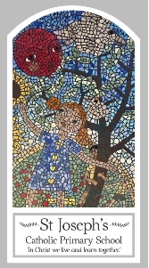
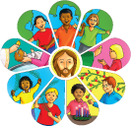
Year Two
Knowledge Organiser
Eucharist – Relating
Topic 5: Thanksgiving
Key Words
Word | Definition
Thank you | A phrase we use to show we are grateful.
thanksgiving | A way of showing you are grateful to God.
thoughtful | When you think of other people and act in a kind way.
Eucharist | When the bread and wine are consecrated.
Eucharistic Prayer | A prayer the priest says when concreting the bread and wine.
Liturgy | A religious service or act of worship.
Scripture
Luke 22: 19-20 – God’s Story 2 page 77

Big Question
Why should we be grateful people?
My first thoughts:

What will I learn?
- To talk about their experience of receiving and giving thanks.
- To say what they wonder about how others feel when they are thanked.
- To recognise the story of the Last Supper.
- To recognise signs and symbols, different words and phrases used in the Eucharist (at Mass) to give thanks.
- To recognise that Catholics go to Mass to remember what Jesus did at the Last Supper and give thanks to God.
- To ask and respond to questions about how they and others feel when receiving and giving thanks.
- To retell the story of the Last Supper.
- To use words and phrases to describe some religious signs and symbols.
- To use words and phrases to describe the steps involved in the Eucharist (Mass) showing how Catholics give thanks to God.
- To describe how Catholics try to live what they have experienced at Mass in their daily lives.

