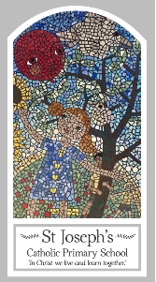
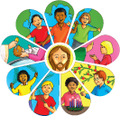
Year Two
Knowledge Organiser
Local Church – Community
Topic 4: Books
Key Words
Word | Definition
books | A book are a collection of information or stories in one place.
library | A place where books of all different types are kept.
Text book | A book you write in.
reverence | A deep respect for something.
respect | A feeling of deep admiration.
Scripture | Sacred book and text often called the Bible.
Lectern | A stand where the bible is placed to read from.
Gospel | A book written by Jesus disciples.
Bible | A collection of religious texts and scriptures.
New Testament | Is the disciples’ stories of Jesus.
Old Testament | A collection of ancient religious Hebrew writings by the Israelites.
genre | Are used by writers to categorise there work.
thurible | A vessel used to burn aromatic incense.
Missal | A liturgical book containing all instructions and text necessary to celebrate mass throughout the year.
Scripture
Matthew 3: 13-17
John 13: 34-35

Big Question
Why do we need books?
My first thoughts:

What will I learn?
- To talk about their experience and feelings of books that are used at home and school.
- To say what they wonder about the importance of books in their lives.
- To recognise that the Bible is a special book and name some of the stories in the Bible.
- To recognise and name some of the special books used in church and the people who use them.
- To ask and respond to questions about their own and others’ experience and feeling of the different books that are used at home and school.
- To retell the story of the Baptism of Jesus.
- To describe how the Gospels are used by the parish family.
- To use religious words and phrases to describe the actions and symbols related to proclaiming the Gospel.

