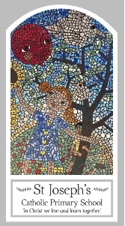
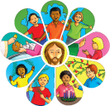
Year Two
Knowledge Organiser
Baptism/Confirmation – Belonging
Topic 2: Signs and Symbols
Key Words
Word | Definition
garment | A piece of clothing.
Easter Candle | A special candle that is lit at the Easter mass in church.
font | A large bowl in a church that holds holy water.
chrism | A special oil which is used to anoint.
Good News | Information that is happy.
sign | An event, an action, a fact etc.. That shows that something exists, is happening now or may happen in the future.
symbols | Something that represents a person, an object, an event, etc.
Scripture

Big Question
Are signs & symbols important?
My first thoughts:

What will I learn?
- To talk about your experience and feelings about signs which help you in daily life and the symbols which are important to you.
- To able to say what you wonder about the meaning and importance of some symbols in your life.
- To ask and respond to questions about the reasons for the importance of certain symbols in your life.
- To ask questions about what you and others wonder about the power of symbols to convey meaning and realise that these questions are difficult to answer.
- To recognise the signs and symbols used in baptism.
- To use some religious words and phrases used in the Sacrament of Baptism.
- To recognise that Christians act in a particular way because they are members of the Church family.
- To use religious words and phrases to describe some actions and symbols used in baptism.
- To describe some ways in which Christians live as followers of the Light of Christ.

