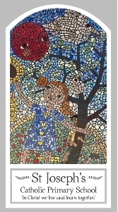
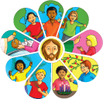
Year Two
Knowledge Organiser
Domestic Church – Family
Topic 1: Beginnings
Key Words
Word | Definition
beginning | The first part of something or the beginning.
New start | The beginning or something new.
Family | A group of people who are related to each other.
friend | A person you know well and like a lot.
creation | The act of creating something.
Psalm | A holy poem or a song one of the 150 created by the bible.
litany | A long Christian prayer in which the person leading the service speaks some parts and the other people at the service speak other parts.
Scripture
Genesis 1: 3, 9, 20, 24-26 God’s Story 2 pages 8-9
Psalm 8: 3-11 – God’s Story 2 pages 28-29
Psalm 139: 14-18 – God’s Story 2 page 37
(teachers’ notes page 96)
Psalm 19: 1-5 – God’s Story 2 pages 28-29
Ephesians 1: 3-5

Big Question
Who made the world and everything in it?
My first thoughts:

What will I learn?
- To be able to recognise the story of Creation as a religious story.
- To be able to recognise and use some religious words and phrases about types of prayer.
- To be able to recognise that people are kind and loving because God made them.
- To be able to say what you wonder about the beauty around them and God creating the world.
- To be able to retell the story of Creation as a religious story or some phrases from the psalms.
- To be able to describe and use some religious words and phrases about types of prayer.
- To be able to describe that people are kind and loving because God made them.
- To be able to ask questions about what you wonder about the beauty around them and God creating the world.

