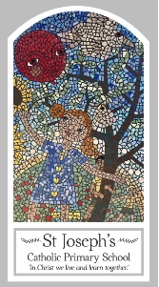
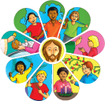
Year Two
Knowledge Organiser
Other Religions - Judaism
Prayer/Home

Key Words
Word | Definition
creation | The act of creating something, or the thing that is created.
Shabbat | Jews often call the day Shabbat, which is Hebrew for Sabbath, and which comes from the Hebrew word for rest.
Challah | The term challah originally referred to a kind of cake.
hydalah | Hydalah is a Jewish religious ceremony that marks the end of Shabbat and users in a new week.
Spice box | It is a box to keep fragrant spices in.
kiddush | Kiddush is a blessing recited over wine or grape juice to sanctify the Shabbat and Jewish holidays.

Topic
Shabbat
My first thoughts:

Look
Families gather

Discover
Shabbat
Respect
Shabbat the day for God, the day of rest

Attainment Targets
AT 1 Learning about religion
i Beliefs, teaching & sources
ii celebration and ritual
iii social & moral practices & way of life
AT 2 Learning from religion
i engagements with own & others’ beliefs & values
ii engagement with questions of meaning

