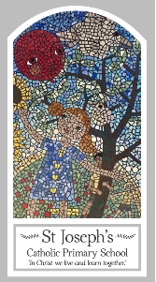
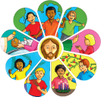
Year 1
Knowledge Organiser
Universal Church - World
Topic 9: Neighbours
Key Words
Word | Definition
neighbour | A person living next door or close by to you.
world | The place where everyone on Earth lives.
Fairtrade | Where farmers receive a fair price for their farming.
Global | The entire world as one.
love | An intense feeling of happiness.
family | The people you are related to.
psalm | A prayer than is often sang.
share | A part of something bigger.
Scripture
Psalm 18: 1-5
Isaiah 12: 4-9: God’s Story 2 page 47
Mark 6: 30-32: God’s Story 2 page 66
Luke 10: 25-37

Big Question
Is the world a treasure?
My first thoughts:

What will I learn?
- To talk about their experience and feelings about neighbours and be able to say what they wonder about neighbours both locally and globally.
- To recognise that everyone is our neighbour and is loved by God, and because of that they act fairly towards others.
- To ask and respond to questions about their own and others’ experiences and feelings about neighbours.
- To retell special stories about Jesus and his friends and describe some ways in which religion is lived out by believers.

