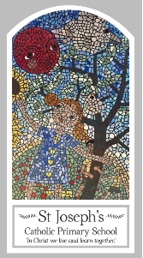
Year One
Knowledge Organiser
Pentecost – Serving
Topic 7: Holidays and Holydays
Key Words
Word | Definition
holidays | Time off from work or school to choose what you want to do.
holyday | Days of religious importance.
Apostles | Each of the twelve disciples of Jesus.
help | To make something easier or to act as a guide.
Pentecost | The descent of the Holy Spirit on the disciples.
promise | A declaration of assurance.
Holy Spirit | Is a part of God.
guide | Something or someone that helps you find your way.
Resurrection | The day Jesus came back to life.
Alleluia | A special word that means celebration.
Scripture
John 14: 26
John 13: 33; 14:18, God’s Story 2 page 81
(Notes page 101)
Acts 2: 1-4 God’s Story 2 page 84-85
(Notes page 101)

Big Question
Do we need Holidays and Holydays?
My first thoughts:

What will I learn?
- To talk about their experience and feelings about holidays.
- To say what they wonder about what makes a holiday a happy time.
- To recognise what a holy day is and the story of coming of the Holy Spirit at Pentecost.
- To recognise some symbols of the Holy Spirit.
- To ask and respond to questions about the difference between ordinary days and holidays and why we have them.
- To retell the story of the coming of the Holy Spirit at Pentecost.
- To describe the ways in which the Holy Spirit is a helper and guide.

