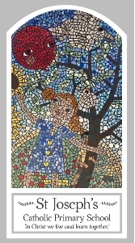
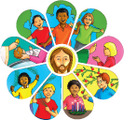
Year One
Knowledge Organiser
Eucharist - Relating
Topic 5: Meals
Key Words
Word | Definition
family | A group of people related to each other.
meal | Food that you eat.
Mass | Is a religious service which celebrate the Eucharist.
share | A part of a portion of a larger amount.
blessing | A gift bestowed by God.
bread | I a staple food prepared from a dough of flour and water usually baked.
host | Consecrated bread.
wine | A drink made from wine.
altar | A special table where bread and wine are consecrated.
Last Supper | The last meal Jesus shared with his disciples before he died.
Holy Communion | The celebration of the bread and wine being made holy.
Preparation of the Gifts | The offertory of the mass.
litany | A special prayer that is used in the mass.
chalice | A special cup where the wine is consecrated.
Scripture
Luke 22: 19-20 – God’s Story 2 page 77

Big Question
What makes some meals special?
My first thoughts:

What will I learn?
- To talk about their experience and feelings about meals which are special to them.
- To say what they wonder about why people share special meals.
- To recognise the story of Jesus’ special meal at the Last Supper.
- To ask and respond to questions about meals which are special to them.
- To retell the story of Jesus’ special meal, The Last Supper.
- To use religious words to say what happens at Communion at Mass.

