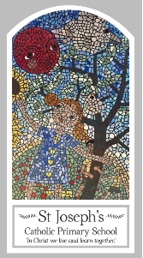
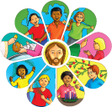
Year One
Knowledge Organiser
Local Church - Community
Topic 4: Special People
Key Words
Word | Definition
Special people | People who we feel a special connection to.
greeters | People who welcome others into church.
Sunday | A holy day and a day of rest.
holy | Dedicated or consecrated to God in religion.
Jesus | God son on earth
Presentation | The day Jesus was taken to the temple to induct him into Judaism.
church | A special building for religious services.
community | People who live near each other who come together.
temple | A special building used for religious services.
Altar servers | A person who helps the priest on the altar.
Extraordinary | Something that is amazing and doesn’t happen all the time.
Ministers | Trained members of the community who give out communion.
Readers | Trained members of the community who read the gospel out loud.
Choir | People who come together to sing.
Cleaners | People who clean a building.
priest | A person who is ordained to perform and administer religious rites.
collectors | People who collect money for charity.
musicians | People who are trained to play musical instruments.
Scripture
Luke 2: 23-40 – God’s Story 2 page 62
Luke 2: 41-52 – God’s Story 2 page 63
(teachers’ notes page 99)

Big Question
What makes a person special?
My first thoughts:

What will I learn?
- To talk about their experience and feelings about the special people they know or have heard about.
- To say what they wonder about the help special people give them.
- To recognise some stories about Jesus’ life.
- To recognise how everyone helps each other because they belong to the parish family.
- To retell some stories about Jesus’ life.
- To ask and respond to questions about what makes a person special

