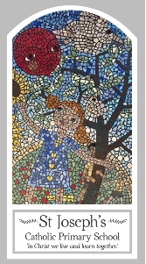
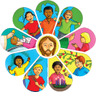
Year One
Knowledge Organiser
Advent/Christmas – Loving
Topic 3: Waiting
Key Words
Word | Definition
preparing | To get ready.
waiting | Means delaying or preparing for something until you are ready.
wreath | ​An arrangement of flowers and leaves, especially in the shape of a circle.
celebrate | To show a day or an event is important you doing something special.
Christmas | The day Christians celebrate the birth of Jesus.
Advent | The four weeks before Christmas.
Jesus | The son of God.
Mary | The mother of Jesus.
Joseph | The man who brought up Jesus as his son.
messenger | Someone who is sent to deliver a message.
manger | A box that cows and horses eat from.
visit | To see a person or place for a period of time.
shepherds | People who look after sheep.
angels | A spirit of God who is sent to deliver a message.
Elizabeth | Mary’s friend and cousin.
Bethlehem | Bethlehem is a city located in the central West Bank, Palestine, about 10 km (6.2 miles) south of Jerusalem.
worship | The act of showing respect by saying prayers or signing songs.
Scripture
Luke 1: 26-31, 38 – God’s Story 2 page 55
Luke 1: 39-45 – God’s Story 2 page 56
Luke 2: 1-7 – God’s Story 2 page 58
Luke 2: 8-20 – God’s Story 2 page 59

Big Question
Is waiting always difficult?
My first thoughts:

What will I learn?
- To be able to talk about your experience and feelings about waiting.
- To be able to say what you wonder about waiting.
- To begin to ask and respond to questions about your own and others’ experiences and feelings of waiting.
- To begin to ask and respond to questions about what you and others wonder about and realise that some of these questions are difficult to answer
- To be able to recognise that Advent is a time of waiting to celebrate Jesus at Christmas.
- To be able to recognise the Advent wreath, calendar, the colour purple and the Crib as religious signs and symbols.
- To be able to use some religious words and phrases about Advent and waiting.
- To be able to retell the story of the birth of Jesus.
- To be able to use religious words and phrases to begin to describe some religious traditions and symbols of Advent and Christmas.

