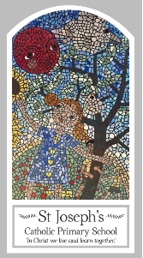
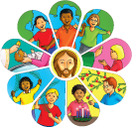
Year One
Knowledge Organiser
Baptism/Confirmation – Belonging
Topic 2: Belonging
Key Words
Word | Definition
Sign of the Cross | The sign we make when we want to speak to God.
belong | To be or feel like you are in the right place.
belonging friends | People who believe in God who come together.
sacrament | An important religious ceremony in the Christian Church.
invitation | An invitation is an invite to a special event.
welcome | To be pleased about encourage or support something.
Baptism | A sacrament of welcoming someone into the church family.
godparents | People who are chosen to help with someone’s spiritual journey.
font | A large container which contains holy water.
sign | Is like a symbol or something that gives you information.
Scripture
Mark 10: 13-16; God’s Story 1 pages 30-31

Big Question
Why is welcome important?
My first thoughts:

What will I learn?
- To be able to talk about their experience and feelings about belonging to different groups.
- To be able to say what they wonder about belonging and what that means.
- To be able to ask and respond to questions about their own and others experiences of belonging to different groups.
- To be able to recognise and use some religious words and phrases used in Baptism, such as ‘I baptise you in the name of the Father…’
- To recognise that Baptism is the beginning of life in the Church family.
- To be able to ask questions about what they and others wonder about Baptism and becoming a Christian and realise some of these are difficult to answer.
- To be able to use religious words and phrases to begin to describe some actions and symbols used in a Baptism ritual such as pouring of water, anointing with oil, lighting the baptismal candle etc.

