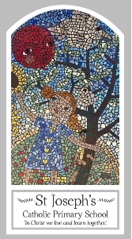
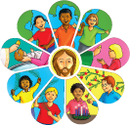
Year One
Knowledge Organiser
Domestic Church – Family
Topic 1: Families
Key Words
Word | Definition
God’s children | Children who are born into God’s family.
psalm | A holy poem or song especially one of 150 collected together in the Bible.
Family of God | People who believe in God who come together.
Response | An answer or reaction.
Family | A group of people who are related to each other.
Belong | To be in the right place.
God | A spirit or being that is worshipped.
Love | To have strong feelings of liking for a person.
Care | The process of protecting someone or something and providing what a person needs.
Different | Things that are not the same.
Scripture
Psalm 63: 6-9 God’s Story 2 page 31
(teachers’ notes page 96)
Psalm 16: 7-9 God’s Story 2 page 30
Psalm 28: 6-8
Luke 12: 27-30

Big Question
Why do we have a family and
who is my family?
My first thoughts:

What will I learn?
- To be able to recognise the stories and psalms which reveal God’s love and care.
- To be able to retell some of the psalms and something about Jesus’ childhood.
- To be able to say what they wonder about the care given to people within families.
- To be able to ask and respond to questions about the difference between families.

