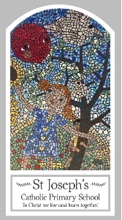
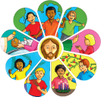
Early Years
Knowledge Organiser
Universal Church - World
Topic 9: Our World
Key Words
Word | Definition
world | The place where everyone on Earth lives.
wonder | A feeling of surprise or amazement.
Wonderful | A feeling of real happiness.
care | To look after someone or something.
love | An intense feeling of happiness.
share | A part of something bigger.
work | Something you do to achieve a goal.
play together | What you do with your friends.
Scripture
Genesis 1: 3, 9, 20, 24−26, God’s Story 1, pages 4-7
(teachers’ notes, page 42)
Psalm God’s Story 1, pages 8-11
(teachers’ notes page 42)

Big Question
What makes our world so wonderful?
My first thoughts:

What will I learn?
- To recognise some words and phrases from the Psalms and recognise that people want to take care of the world and share with others because God said, “Take care of my world!”
- To say what they wonder about the world and how we can all work together to care for the world
- To be able to talk about their own experiences of the world and what they love about our world.

