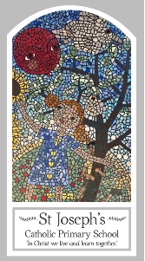
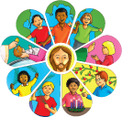
Early Years
Knowledge Organiser
Reconciliation – Inter-relating
Topic 8: Friends
Key Words
Word | Definition
friend | A person you have a close bond with and feel you and trust.
happy | A feeling you have when you smile.
sad | A feeling you have if something has gone wrong.
love | A feeling for someone who you have a deep connection.
make up | When you try to make things right if they have gone wrong.
kind | When you show someone that you like them.
gentle | Showing someone you a kind.
loving | Inner happiness that is shown to others.
sorry | A word we use to make a mends for our actions.
Jesus | God’s son sent to live on Earth.
forgive | To stop feeling angry towards another person.
change | To not keep doing the same thing to try something new.
rule | A statement telling people how to behave.
understanding | When you see things from another person’s perspective.
new start | When you make a change.
friendship | What people share when they are close to another person.
Scripture
Mark 6: 7, 30-32 God’s Story 2 page 66
(Notes page 99)
John 13: 34 God’s Story 1 pages 32-33 Nursery
John 13: 34-35 God’s Story 2 pages 72-73 Reception
(Notes page 100)

Big Question
Is it good to have friends?
My first thoughts:

What will I learn?
- To talk about their experiences and feelings about what a friend is.
- To talk about making friends and when friendships go wrong.
- To wonder about what makes people friends.
- To recognise that Christians show love for one another because Jesus asked them to do so.
- To recognise Jesus’ rule for friends and his words ‘love one another’.

