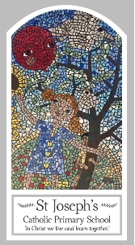
Early Years
Knowledge Organiser
Pentecost - Serving
Topic 7: Good News

Key Words
Word | Definition
Good News | Information that makes people feel happy and positive.
share | A part of something can be shared to others.
Pentecost | The decent of the Holy Spirit on the disciples.
promise | To pledge to do something.
Holy Spirit | Is God’s power in action his active force.
Easter | The day Jesus was resurrected from the dead.
Alleluia | A word of praise and to give thanks.

Scripture
Acts 2: 1-4, God’s Story 1 pages 36-37
(Notes page 50)

Big Question
What is Good News?
My first thoughts:

What will I learn?
- To talk about how they feel when they have good news to share.
- To say what they wonder about the joy good news brings.
- To talk about how they feel when they hear Good News.
- To say what they wonder about Pentecost Day and the Holy Spirit.
- To recognise the Pentecost story as a religious story.
- To use and recognise religious words such as Pentecost, Good News, alleluia, Easter, Holy Spirit.
- To recognise that Christians are happy at Pentecost and go to church to celebrate the Good News.

