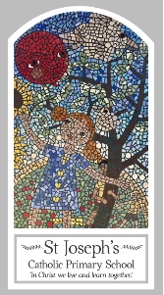
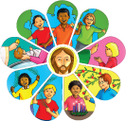
Early Years
Knowledge Organiser
Lent/Easter - Giving
Topic 6: Growing

Key Words
Word | Definition
Grow | When an animal or plant gets bigger in size.
Spring | A season of the year when new life grows.
different | Not a like to anything else.
Lent | 40 days and 40 nights before Easter.
Good Friday | The day Jesus was crucified.
cross | Two pieces of wood that form a cross shape.
Easter | The day Jesus was resurrected from the dead.
Sunday | The day of rest in the week a holy day.

Scripture
John 13: 34-35 God’s Story 1 pages 32-33
(Notes page 48)
John 19: 25-27 God’s Story 1
(Notes page 49)
Acts 2: 23-24 God’s Story 1 page 35
(Notes page 49)
Luke 2: 51-52

Big Question
How and why do things grow?
My first thoughts:

What will I learn?
- To talk about their own experience of ‘growing’.
- To talk about how they feel about ‘growing’.
- To say what they wonder about growing, themselves and in nature.
- To recognise the stories of Good Friday and Easter Sunday as religious stories.
- To recognise the Cross, the words of the Sign of the Cross and the Easter garden.
- To recognise that Christians try to ‘grow more like Jesus’ particularly during Lent.

