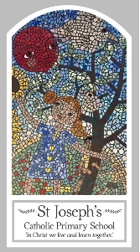
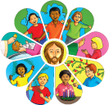
Early Years
Knowledge Organiser
Eucharist- Relating
Topic 5: Gathering
Key Words
Word | Definition
welcome | A kind greeting
blessing | The act or words someone who gives a blessing
listen | Giving attention to the ears for listening.
pray | To talk to God to give thanks or ask for help or healing.
Mass | To gather together to celebrate Gods word.
sing | When we use our voice to create a tuneful notes.
gather | When more than one person comes together.
together | Being with other people.
alone | Being on your own.
Lectern | The place where the bible is placed to read from.
“The Lord be with you.” | Responses we use when we read the gospel.
“And with your spirit” | Responses we use when we read the gospel.

Scripture
Mark 10: 13,14,16
God’s Story 1 pages 30-31
(Notes page 48)

Big Question
What do people gather together?
My first thoughts:

What will I learn?
- To talk about the times they have gathered together with others. Some children will begin to talk about how they felt.
- To say what they wonder about the enjoyment of being together.
- To recognise the story of Jesus with the children as a religious story.
- To recognise the phrases “The Lord be with you.” “And with your spirit.”
- To recognise the Lectern and know how it is used.
- To recognise how people gather together to share the stories of God’s love at Mass.
- To talk about their experience of visiting church and listening to God’s word.

