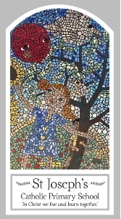
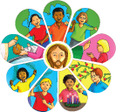
Early Years
Knowledge Organiser
Local Church – Community
Topic 4: Celebrating
Key Words
Word | Definition
Church | A building for public Christian worship.
priest | A priest is a religious leader that performs sacred rituals of religion.
Celebrate/celebrating | Acknowledge (a significant or happy day or event) with a social gathering or enjoyable activity.
Parish family | The parish family is a living community and part of Christian family.
family | A group of people who are related.
community | A community is a social unit.
celebration | A special social event, such as a party, when you celebrate something
party | When people get together to celebrate.
memory | Memory is the faculty of the brain by which data or information is encoded, stored, and retrieved when needed.
Priest | A person, usually a man, who has been trained to perform religious duties in the Christian Church,
Father | Can be a dad or another name for a priest.
altar | The table in a Christian church at which the bread and wine are consecrated in communion services.
Temple | Is a building reserved for religious or spiritual rituals
parish | A Christian group of people who live in the same area.
Scripture
Luke 2: 22b – God’s Story 1 pages 28-29
(teachers’ notes page 48)

Big Question
What and why do people celebrate?
My first thoughts:

What will I learn?
- To begin to talk about your own experiences and feelings about celebrations they have been part of and how the celebration was shared.
- To begin to wonder about why people celebrate.
- To begin to wonder about how they feel when you celebrate.
- To begin to recognise the story of Mary and Joseph taking Jesus to the Temple.
- To begin to recognise some of the elements and words used in church celebrations.
- To begin to recognise that the church/parish family celebrate in particular ways.

