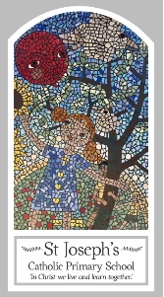
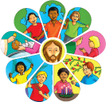
Early Years
Knowledge Organiser
Advent/Christmas – Loving
Topic 3: Birthday
Key Words
Word | Definition
birthday | The day in each year which is the same date as the one on which you were born.
waiting | Means delaying or preparing for something until you are ready.
wreath | ​An arrangement of flowers and leaves, especially in the shape of a circle.
celebrate | To show a day or an event is important you doing something special.
Christmas | The day Christians celebrate the birth of Jesus.
Advent | The four weeks before Christmas.
Jesus | The son of God.
Mary | The mother of Jesus.
Joseph | The man who brought up Jesus as his son.
swaddling clothes | To wrap up a baby tightly in a piece of cloth.
manger | A box that cows and horses eat from.
crib | A small bed for a baby.
shepherds | People who look after sheep.
wise men | Men who studies the stars.
Scripture
Luke 2: 8-20 - God’s Story 2 page 59
Luke 2: 4-7 God’s Story 2 page 58
God’s Story 1 pages 24-25, 26-27
(teachers’ notes pages 46-47)
Matthew 2: 1-12 - God’s Story 2 page 60

Big Question
Why do we celebrate Birthdays?
My first thoughts:

What will I learn?
- To begin to talk about their own feelings as they wait for a birthday.
- To begin to talk about their own experience of celebrating a birthday.
- To begin to wonder at the joy of birthdays.
- To begin to recognise the Christmas story.
- To begin to recognise that the Advent Wreath, the crib and other signs indicate the approach of Christmas.
- To begin to use and develop a vocabulary of religious words and phrases.

